Jonathan Quang Math Research

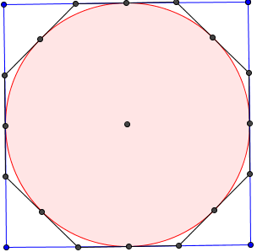 Pi is the ratio of the circumference of a circle to its diameter, used by students since elementary school. However, there is more to pi than a simple ratio. People expect values of pie to be calculated just by pressing a button, but how is it done without a machine? The population of those who know how to calculate the value of pi is much smaller compared to the people who know how to calculate pi.  
 The problem with pi is that it is irrational. An irrational number is a number that cannot be expressed as a ratio between integers such as $\frac{2}{3}$. The common approximations of pi are $\frac{22}{7}$ which is only accurate up to two digits, $\frac{333}{r6}$ which is accurate only to five digits, and $\frac{355}{113}$. There will never be an exact fraction, but there is a way to find these fractions.  
 One way to approximate pi is through the application of Pythagoras’s theorem to a circle inscribed in a regular concave polygon. Using a circle inscribed in a regular concave polygon inscribed and inscribed in another regular concave polygon with 2 times the number of side will yield a high end approximation. A common polygon to start with is a square. Imagine a circle inscribed within a square and inscribed within an octagon, as with the picture below.  
 Say the radius of the circle is 10. Now the square’s side is twice the radius, 20. The perimeter of the square is four times a side, so the perimeter of the square is 80. The diameter of this circle is 20. Pi is defined as the ration of the perimeter to the diameter, so the ratio is $\frac{80}{20}$, or 4. However, finding pi using a regular concave octagon becomes slightly more complicated. It is acknowledged that the length of the midpoint on one side of the square to another side of the square is 10. The midpoints of the sides also function as midpoints of the sides of the octagon. The goal is to find the length between a midpoint of the side of an octagon to one of the vertices of the octagon. We define this length as b. If one draws two triangles that each use a measurement of b and another variable, then b can be found. This is accomplished by drawing a line segment from one vertex of the square to the center of the circle. The length of this segment with the radius removed is defined as c. Now two right triangles have been formed. Applying the Pythagoras’s theorem to two of these triangles yields b2 + c2 = (10 – b)2 and (10+c)2 = 102 + 102. The overall goal is to find b through substitution by isolating c first. In b2 + c2 = (10 – b)2, b2 can be subtracted from both sides to get c2 = (10 – b)2 – b2. Squaring the binomial contained in the parentheses yields c2 = 100-20b +b2 – b2, which simplifies to c2 = 100 – 20b. With (10+c)2 = 102 + 102, square rooting both sides will yield 10+c = $\sqrt{{10}^{2}+{10}^{2}}$. Subtract 10 from both sides and c = $\sqrt{{10}^{2}+{10}^{2}}$– 10. C is now isolated on both sides of the equation, c2 = 100 – 20b and c = $\sqrt{{10}^{2}+{10}^{2}}$– 10. Substitute the c and now ${(\sqrt{{10}^{2}+{10}^{2}} – 10)}^{2}$ = 100 – 20b. Subtract 100 from both sides of equation, and now ${(\sqrt{{10}^{2}+{10}^{2}} – 10)}^{2}$ = -20b. After evaluating the left side of the equation, 17.15728753…= -20b. Dividing both sides by -20 will finally yield the value of b, which is 4.14213569…  
 With the value of b evaluated, the perimeter of the octagon can now be found out. Since b represents the length of one half of a side on the octagon, 2b represents the length of one side. Since the octagon is equilateral, all 8 sides are equal, so the perimeter is 8\*2b, or 16b. This makes the perimeter about 66.27416998… The diameter of the circle is 20 because the diameter is twice the radius, 10. The ratio of pi is defined as the ratio between the perimeter of a circle and its diameter. Since the octagon is being used to approximate the perimeter of a circle, pi is about $\frac{66.27416998…}{20}$ or about 3.313708.

If a 16-gon is inscribed in the circle, 2b now becomes the length of one side of the octagon. After that, if a 32-gon is inscribed in the circle, 2b now becomes the length of one side of the 16-gon and so on. As the number of sides the polygon has increases, the polygon becomes closer and closer to looking like a circle. As the polygon becomes closer and closer to looking like a circle, the approximation of pi becomes more accurate. As the number of sides increases however, the diagram becomes increasingly complex. However, there is a formula for approximating pi that uses only the number of sides and a value for a.

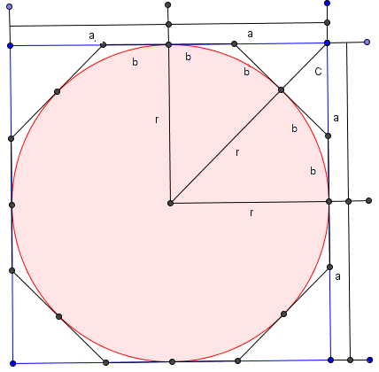Say the radius of the circle is r. The length of one side of a polygon is defined as 2a. The length of a side for a regular concave polygon that has twice the number of sides (the octagon) of the other polygon will be represented by 2b. C represents the length described in the picture to the right. Variables will be used instead of actual values because picking values for a, b, or c will be inaccurate because they may not be correct. The first goal to achieve in calculating pi is finding the ratio of the length of one side of the radius without using the fact that each side of a square is twice the radius. To accomplish the first goal, two right triangles are defined by their side lengths. Triangle r is defined as having a side length of a and a side length of (r+c). Since r represents r, the side length is (r+c). Triangle b is defined as having a side length of c and (a-b).   
 The next part of finding pi would be applying Pythagoras's theorem to each triangle in the following manner: In triangle r, (r+c) is the hypotenuse. Therefore (r+c)2 = r2 + a2. In triangle b, (a-b) is the hypotenuse. Thus, (a-b)2 = b2 + c2. Going back to the application of Pythagoras's theorem to triangle b, the squares can be multiplied out to form b2 + c2= a2- 2ab + b2. This can be simplified by subtracting b2 from both sides and yields c2= a2- 2ab. Return to the application of Pythagoras's theorem to triangle r, (r+c)2 = r2 + a2, square rooting both sides yields r+c = $\sqrt{r^{2}+ a^{2} }$, which simplifies to c = $\sqrt{r^{2}+ a^{2} }- r$. With these two equations setup in this manner, they both have the variable c in common.  
 If we plug the simplified equation for triangle r into the simplified equation for triangle b, the result is ${(\sqrt{r^{2}+ a^{2} }- r)}^{2}= a^{2}- 2ab.$ If one were to square the equation for triangle r, the result is $r^{2}+ a^{2}-2{*r\sqrt{r^{2}+ a^{2} }- r}^{2}$ = $a^{2}- 2ab$. Combining the r2 on the triangle r side of the equation, subtracting a2 from both sides of the equation, and multiplying by -1 yields 2ab=2 ${r\sqrt{r^{2}+ a^{2} }-2* r}^{2}$\*. To isolate b, both sides of the equation should be divided by 2a. This yields b = ${r\sqrt{\frac{r^{2}}{a^{2}}+ \frac{a^{2}}{a^{2}} }-\frac{ r}{a^{2}}}^{2}$. Factoring out the r2 results in b = r2 ). Dividing both sides by r results in $\frac{b}{r}=r\left(\sqrt{\frac{1}{a^{2}}+ \frac{1}{r^{2}} }-\frac{ 1}{a}\right).$ By doing so, we are finding the ratio of the length of one side to the radius. Redistributing the r among the terms in the parenthese yields $\frac{b}{r}=\left.\sqrt{\frac{r^{2}}{a^{2}}+ \frac{r^{2}}{r^{2}} }-\frac{ r}{a}\right..$ Simplifying this results in $\frac{b}{r}=\left.\sqrt{{\left(\frac{r}{a}\right)}^{2}+1 }-\frac{ r}{a}\right..$ To have all variables be a ratio to r, one must realize that $\frac{r}{a}$ = $\frac{1}{a/r}$. This allows $\frac{b}{r}=\left.\sqrt{{\left(\frac{r}{a}\right)}^{2}+1 }-\frac{ r}{a}\right.$ to be $\frac{b}{r}=\left.\sqrt{{\left(\frac{1}{a/r}. \right)}^{2}+1 }-\frac{1}{a/r}. \right.$ Here, b is expressed as a ratio to the radius. This leads to the next portion of the algebra.  
 For the sake of clarity, ε will equal to a/r and β will equal b/r. Substituting these into the equation results in $β=\left.\sqrt{{\left(\frac{1}{ε}\right)}^{2}+1 }-\frac{ 1}{ε}\right.$. The goal of finding the ratio of one side of the polygon with more sides to the radius. In this case, the polygon selected has 4 sides, and the octagon it is inscribed in has 8 sides. rβ represents half the length of one side. If one defines N as the number of sides the polygon with more sides has, then 2Nrβ would represent the perimeter of the polygon with twice the number of sides as the chosen polygon. The diameter is 2\*r. Dividing the perimeter by the diameter, which is finding the formula for pi, will yield, N\*β. Since this formula relies solely on ratios and not the size of any of the segments, pi is the same regardless of size of the selected polygon.   
 A square and an octagon can be used to show an example of using this formula. β(square) = 1 and pi is about 4. This is due to the fact that the length of one side of a square is equal to the diameter. The perimeter is equivalent to four times the diameter. Consequently, β = 1. Starting with an octagon, the formuls will be applied properly. For the sake of finding pi, ε=1. Applying this to β, β = $\sqrt{2}$-1, or about 0.414. Pi is about N \*β, so pi is about 8 \* 0.414, or 3.312. This is a high end estimate. To get an even more accurate estimate, finding the low end estimate and averaging the two estimates would be perferebly.  
 To find the low end estimate, the ratio of the perimeter of a regular concave polygon inscribed within a circle to the circle’s diameter must be found. Once again, polygons with a power of 2 number sides will be used exclusively. If a square is inscribed within a circle with a radius of ten, the length of a segment from one vertex to the center of the square is the same as the radius. Two segments formed from two adjecent vertices forms a right triangle where the hypotenus is the length of the radius and the lengths of the triangle are equal. Using one’s knowledge of pythagorean triple, if the legs of a right triangle are equal, then the hypotenuse is $\sqrt{2}$ multiplied by the length of one leg. Since each side of the square is $\sqrt{2}$ times the radius, the perimeter of the square is 4 $\sqrt{2}$ times the radius, 10, and the diameter is 20. This makes the perimeter of the square 40 $\sqrt{2}$. This makes the low estimate of pi to be about $\frac{40\sqrt{2}}{20}$, which is   
2 $\sqrt{2}$ or 2.82842125...

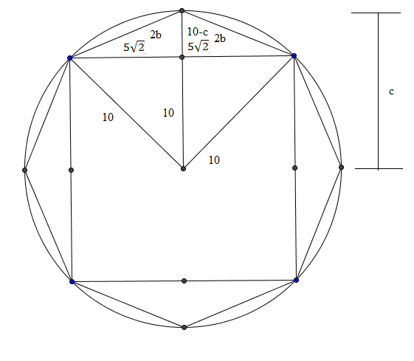Much like finding the high end estimate, finding the perimeter of a regular concave octagon inscribe within the circle becomes more complex. Unlike finding the high end estimate, the square is inscribed within the octagon, which is then inscribed within the circle. Each side of the square is 10 $\sqrt{2}$ (making the length from the midpoint of a side to a vertex 5 $\sqrt{2}$), the radius is 10, 2b represents the length of one half the side of the octagon, and c represents the length of the segment drawn from the center of a midpoint of the octagon to the center of the circle. Consequently, the two divided segments that result from the midpoint on the octagon each represent b. The distance of a segment from the midpoint of the suare to the vertex of the octagon is 10-c. There are two right triangles in the diagram. One right triangle has the legs c and 5 $\sqrt{2}$ and a hypotenuse of 10 (the radius). Applying pythagoras's theorem to this right triangle will result in c2 + (5)2 = 102. Subtracting (5)2 from both sides will result in c2 = 102 -(5)2 Square rooting both sides will yield $c= \sqrt{{10}^{2}-{(5\sqrt{2})}^{2}. }$ In the right triangle created by the legs 5 $\sqrt{2}$ and c, and the hypotenuse, 2b, the application of Pythagoras's theorem comes out to ${(5\sqrt{2})}^{2}+{(10+c)}^{2}= {(2b)}^{2}$. Squaring the 2b gets ${(5\sqrt{2})}^{2}+{(10-c)}^{2}= {4b}^{2}$. These two equations now share a term in common, c. By substituting the first equation into the second equation, the variable c has been eliminated and ${(5\sqrt{2})}^{2}+{(10-\sqrt{{10}^{2}-{(5\sqrt{2})}^{2} })}^{2}= {4b}^{2}$. Evaluating the value of the left side of the equation, dividing it by 4, and then square rooting it will have b to be about 3.82684324. Recall that the length of each side is 2b and there are 8 sides. This makes the perimeter of the regular octagon 16b. Evaluating this expression will yield 61.22934918... Recall that the diameter of the circle is 20. Calculating the ratio of pi with the perimeter of the octagon as an approximation will yield 3.031467459... To get an even more accurate estimate, the number of sides with the next regular polygon must double. Much like finding the formula for approximating a high end estimate, a formula for finding the low end estimate can also be derived.